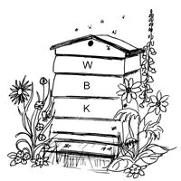
SURREY BEEKEEPERS' ASSOCIATION

WEYBRIDGE DIVISION

NEWSLETTER: July 2017

www.weybridgebeekeepers.weebly.com

Editorial
From the readings on my scale hive (see p. 6), observations of the behaviour of the bees and also reports from other beekeepers, I am wondering if the main honey flow stopped before the end of June. I have had a rather disappointing year with no spring flow (despite abundant Horse Chestnut in flower), and an early start to the main flow in early June which has not developed as one would have expected (despite abundant Sweet Chestnut in flower). Our Seasonal Bee Inspector reported very variable honey flows in our area that reflect some comments from our own beekeepers. If the flow has indeed stopped, I think that we should not remove much honey from our colonies now – there are some big colonies around that may need it this month. In August at the earliest we can carefully assess their stores – we don’t want our bees to starve. We have already had recent and less recent warnings from the National Bee Unit of possible starvation of colonies, and I would not be surprised to have more. I had to feed one or two of my own colonies a little as recently as early June. By the way, if you have not yet done so, make sure to register on “BeeBase” to receive any further alerts as well as accessing much other useful information from the Fera National Bee Unit. Registering with the BBKA does not automatically put you on BeeBase; they are separate databases.

Potential Beekeeping Centre in Pleasant Place, Hersham: Update 7.
After last month, when things seemed to be moving rather slowly, I am pleased to report significant progress this month. We have received the final Heads of Terms from the council. I would stress this is not the final contract, that comes after and is far more detailed. We have gone back to say that, in principle, this is acceptable, although there are a few things we will try and ask the councillors to change when it goes for approval. The next step is that the Heads of Terms agreement goes to a mini cabinet meeting of the council for approval. Assuming we receive this approval, at that point we shall have, in principle, approval from the Council to take out a lease on Pleasant Place, but are not committed to doing so until we move forward and sign an actual contract.
Because of the summer break, the timing of this meeting with cabinet members may now not be until mid September. Once we have this approval then we can move forward and obtain detailed cost estimates for the work that is planned to be done. We need these both to raise funds from grant bodies and also so that we can present them at the EGM for our members to approve the overall project. This will now realistically not be until towards the end of 2017. Based on these timings we would expect if all things go smoothly to be able to open the new premises towards the end of 2018 with bees moving onto the site early in 2019 for the 2019 beginners’ course to be held there.
As part of the process we have also now engaged with the Building Control team for Elmbridge Council. Planning is all about how a place looks and the use to which it is put. Building Control ensure that the planned work is done in line with Building Regulations. The good news is that we were concerned over the level of adjustments to the property we may have to make to comply with regulations and whilst these are still significant, they are not to the extent that we had feared they might be.
In summary, therefore, a lot of progress this month. However, it may be that things will now slow down again until the date of the council meeting is confirmed when the Heads of Terms are hopefully approved.
David Parker
REPORTS
Report on the June Garden Meeting at Garsons Farm, Esher
Our June meeting took place on the hottest day of the year so far, when 12 members gathered to pick up some tips from Peter Bowbrick who had been a Bee Inspector for some years. Two items were covered, firstly by short talks in relative coolness (without full bee suits & gloves) followed by a warmer apiary inspection. The customary tea took place in a shady spot, away from the fruit pickers and bees. This was accommpanied by a helpful discussion with contributions on beekeeping topics and experiences.
Disease Inspection. Peter encouraged us to undertake 2 inspections every year solely for the purpose of inspecting for disease. Each frame must be inspected, after shaking or brushing as many bees away as possible. Whilst some problems may be visible on many frames others may be confined to a single frame.
We should all recognise healthy unsealed larvae (curled, white and segmented) and sealed brood and be concerned about anything that does not look ‘normal’. If in doubt .... ask ! (either someone within your club or call the Bee Inspector - contact details at the end of each newsletter).
Peter extracted a larva using tweezers (always kept in his bucket of soda) and showed us that a streak of yellow or orange indicates the larva is being fed on pollen. As European Foul Brood feeds on the gut of the larvae it will appear white and hard. American Foul Brood is much more serious so we should all be aware of the symptoms, however, fortunately it is much less common.
Sadly much of the disease encountered in apiaries is spread by beekeepers, so we all need to be aware of basic hygiene as well as what to look out for.
Queen Marking and Clipping. Peter routinely marks and clips his queens at the same time. Marking is undertaken using the standard 5 yearly colours to help identify the age of each queen. The discovery of an unmarked queen in the colony indicates that a queen may have been superseded, however sometimes the marking can rub off ! (mainly from water based paints – white seems to be the most permanent colour). Some of the group practiced this by marking drones.
Clipping one of the queen's wings prevents her from flying too far when swarming. The remainder of the swarm soon realises the queen is not with them so they fly back to find her (often on the ground a few feet from the hive), giving the beekeeper a chance to rescue the swarm.
Many thanks to Peter for giving us the benefit of his knowledge and teaching skills to give us such an enjoyable afternoon. Paul Bunclark
Thank you, Paul, for this comprehensive, informative and interesting report.

EVENTS IN JULY
Summer meeting, July 22nd, 2.30pm, at Rowtown, Addlestone with Paul and Helen Bunclark
Attached is the PDF of the map of how to get to our field, for the July garden meeting. I’ve also managed an aerial view. It’s a very beautiful spot ! We will have cut the grass so there will be plenty of hay for smokers and there are also piles of wood chippings – just bring a sack or 2! I have also dismantled a caravan with an aluminium roof, so if anyone wants to make some nuc or hive lids they should come and see me.
We have facilities to make tea and coffee, so no need to bring flasks and mugs. There is also a toilet.
Note from Geoff and Marion Cooper regarding the above meeting:
A few days ago, we had the pleasure of visiting Paul and Helen on their site and seeing their apiary, set in many acres of lovely fields and woodlands within a mile or so of Addlestone. Over the years we have been to many garden meetings in beautiful areas, but this place is really special. Do come to this meeting if you possibly can. All that is needed is a contribution of food for the picnic.

Timetable of Weybridge Summer Meetings

Hosts | Date | Status | Main Subject | Secondary Subject
Paul and Helen Bunclark | July 22nd | Confirmed | Finding queens, various methods | Varroa monitoring, various methods
Chris Burnett | August 12th | Confirmed | Demonstration of Top Bar Hives | Making an Asian Hornet trap from a 2-litre Pop bottle.  Demonstration of how to search for small hive beetles in a hive.
 | September | TBC | End of Season Social | Location TBC
FUTURE EVENTS

Training Course for new beekeepers next year and Taster Days this year
As soon as the 2017 theory and practical course has been completed it is time to start preparing for the 2018 course. A ten-week theory course for people wanting to become beekeepers will start at 7.30pm on Monday 22 January 2018 at the Hersham Community Trust hall in Burhill Road, Hersham. This will be followed by a ten-week practical course on Saturday mornings starting in late April at the division’s teaching apiary in Weybridge. The cost of the course is £125.
For prospective beekeepers who want to see inside a hive before committing to the course, there will be two free ‘Taster days’ on Wednesday 16 August at 6.30pm and Saturday 19 August at 2pm. If you know anyone who may be interested in the course or a taster day, please ask them to book a place by contacting Sue Lawes, 29 Sayes Court, Addlestone, KT15 1NA or slawes@hotmail.co.uk Early booking is advised in order to secure a place as numbers are limited.
Andrew Halstead

Surrey BKA AGM, Saturday 2nd December 2017, 2pm to 5pm
The Surrey AGM will be at Trinity School, Shirley Park, Croydon CR9 7AT. Booked from 2pm-5pm.
The speaker is Karen Alton of Sussex University talking on "Plants, Pollination and Bees".
More information on the speaker and the talk, directions and car parking arrangements, etc., will be given nearer the time.
Julie Hogarth - Secretary Surrey Beekeepers Association

Courses at LASI (University of Sussex)
Three courses are available as follows:
Breeding and Using Hygienic Bees
Determining the Most Attractive Plants for Bees and other Flower Visitors
Integrated Varroa Management
See this link for full details: http://www.sussex.ac.uk/lasi/newsandevents/events

National Honey Show, Sandown Race Course, Esher, 26-28 October
Details in April Newsletter, page 4 and on the National Honey Show website.

ITEMS OF LOCAL INTEREST
Fundraising - Waitrose
Further to my report in the June newsletter of the £412 we raised through Waitrose in Weybridge, and my request for volunteers to approach their local branch of Waitrose, I am pleased to report that Anne Miller has kindly volunteered to approach Hersham and Steven Ward to approach Cobham. Many thanks for these kind offers.
That does, however, still leave branches at Esher and West Byfleet. Is anyone willing to approach either of these? If you are local to one of these would you please consider acting on our behalf to help raise funds, it really is very little effort? Please contact me for further information and so we can coordinate efforts.
Martin Major
As you can see, Martin is doing a great job in swelling our funds. Do support him if you are able to.

BeeCraft photographic competition
Congratulations to David Parker for becoming the third Weybridge member to be a winner in the BeeCraft competition with the photograph of his daughter that is on the cover of the July issue.
Who will be the fourth?

A new custodian for the Association’s extractor
We are pleased to announce that a new custodian has volunteered to look after and administer the above. For those unfamiliar with the equipment it comprises a 3-frame stainless steel manual extractor and a separate 100lb stainless steel settling tank c/w integral strainer. It is available for members to hire at £5.00 / day or part thereof. A refundable £10.00 deposit is charged on collection. This will be forfeited if the equipment is not returned clean, complete or not fit to be passed to the next hirer.
Please note that it is important to use NOTHING BUT COLD WATER when cleaning the extractor. Hot water will form a thin film of wax on the cage and drum of the machine that will be very difficult to remove. Also traces of detergents, etc. could be left which would contaminate future extractions. A good method of cleaning after use is to use a high pressure garden hose.
The new custodian is Anne Miller, one of our committee members.
Contact details: e-mail. anne_r_miller@hotmail.com
The equipment will be in her possession after the committee meeting on 6th July.
Many thanks Anne for taking on this task.
Rob Chisholm
Also many thanks to Rob, who organised the purchase, maintenance and lending of this equipment for several years.

Custodian wanted for more Weybridge equipment
As you will have seen in the June newsletter, one of our members, Phil Watkins, very kindly donated equipment to us, including a Thomas honey extractor which incooperates a strainer. We are now looking for a member to house this extractor and arrange for its hire by our members. We are fortunate that our Division now has two extractors, this one and the one described in the previous article. If you would like to help with this second one, please contact our Secretary, Jane Hunter – contact details on last page.

Burhill Allotments apiary site
The Weybridge division has managed an apiary site on Burhill Allotments in Hersham (owned by Walton Charity) where members could put their hives. This has been a successful site for a number of years but in 2017 there was a problem with aggressive bees following and sometimes stinging plot holders. As a consequence of this, the five beekeepers with hives in the apiary were told by Walton Charity to remove them from the site. Walton Charity has indicated that they want to have bees on the site again but it would have to be a single beekeeper site, rather than a shared apiary.
The Weybridge division will not be continuing to rent the site after October 2017. If a Weybridge member wants to take on the apiary for their own bees, they will need to make arrangements with Walton Charity as an individual beekeeper. Anyone contemplating this should be aware that there is potential for further conflicts to arise between bees and plot holders if they get chased or stung by a bee. This may result in the beekeeper being asked to remove his/her bees at short notice.
The Weybridge division has another apiary site at Rowtown where there is space for additional hives. For further details, contact Rob Chisholm – see Contact Details at the end of this newsletter.
Andrew Halstead (Chairman)

When the worst happens……. “I’m afraid the bees will have to go.”
The telephone call came several weeks after the first stinging on an adjacent allotment had been reported.
An aggressive colony believed to be the culprit had been destroyed there and then and two inspections by experienced beekeepers in Weybridge Beekeepers had been carried out. Our landlords (Walton Charity) got a third opinion from an independent beekeeper from the BBKA list. All had said the bees weren’t aggressive and suggested re-queening of another suspect colony.
Despite the best efforts of all 5 beekeepers on the apiary site to identify and re-queen the problem colony, incidents of stinging, chasing, head-butting and following gathered momentum. When the eviction order came, we all had to find suitable sites (at least 2 miles away) and move out as quickly as possible. It was done but not without heartache. One beekeeper gave up and sold her hive. Another could only find a place for one of his colonies and ended up destroying the other.
What can be learnt from this sad tale?
- Have a back-up site to which you can move your bees immediately at the first complaint.
- Listen to complaints and empathise. It is unacceptable if your bees are stinging neighbours.
- Be really picky about where you place your bees. Everybody loves doing their bit for the environment until the first sting. Well away and out of sight from the public is best.
- When problems arise, don’t think as a beekeeper and just try to solve the problem. The complainants are only interested in their problem - your horrible bees - being removed as quickly as possible.
- People will tell you what you are doing wrong as a beekeeper. The internet allows people to become expert beekeepers within just an hour. We were accused of deliberately keeping bad bees so they would make more honey.
- Monitor and record temper and behaviour of your bees on hive records at every inspection. Sometimes bad temper may be temporary but if it persists you need to do something and quickly before it’s a crisis. Books tell you what to do – re-queening – but this takes 6 weeks and angry neighbours won’t wait.
Burhill Apiary had been on the site since 2010 without incident. We never identified the cause of the aggression or which colony was the “Beast of Burhill”. We never found out exactly how many reported stings there were.
Edwina Wardle (previously Burhill Apiary Manager)

The Committee held a Meeting specifically to discuss this apiary and would like to record their thanks for the professional way the bees have been managed at this site, initially by Jim Joyce, the first Apiary Manager, and after that by Edwina Wardle. Their mangagement of the bees and advice / assistance given to the beekeepers there was very much appreciated. The beekeepers were welcomed until adjacent plot holders started to be stung. This coincided with some scrubby screening being removed from around the apiary (not by the beekeepers) and the situation subsequently deteriorated. Given time, the few ‘aggressive’ bees would have been dealt with, but with the site more exposed, further problems could have arisen, so the bees were removed as requested – a sad ending to what had been a mainly enjoyable experience for all concerned.

Honey matters
As further evidence of the variable honey flows, I received this note from Andrew Halstead:
In the recent newsletter, Geoff queried whether there had been a spring flow this year. There was in my apiary in Wisley Garden. It happened during April, with very little coming in during May. On 2 May I extracted 42 pounds from the two stronger colonies of my three hives.

Reports from three scale hives in the Division

(1) From David Parker (Chobham area)

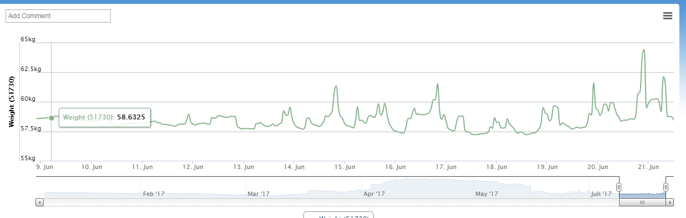
(2) From David Brassington (West Byfleet)

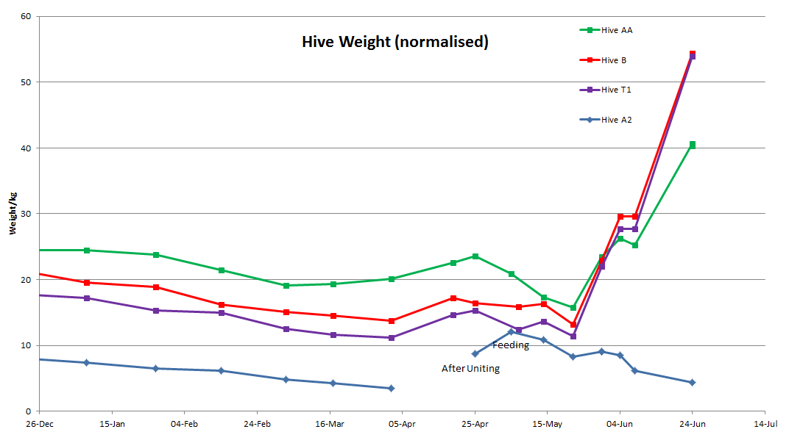
(3) From Geoff Cooper (Hersham)

Date Cumulative change (from 31st June)
31/5 0
1/6 - 2/6 2lb 8oz
3/6 – 6/6 0lb 14oz
7/6 – 17/6 22lb 5oz
18/6 – 23/6 45lb 10oz
24/ - 1/7 50lb 10oz

It’s interesting that the hives in Hersham and West Byfleet show a sudden increase of weight over a similar period, but that in the Chobham area remained fairly static. This reflects the comments made in the editorial. I think that it is worthwhile to continue with the measurements, although I don’t feel very optimistic about a further significant flow.

ITEMS OF GENERAL INTEREST

The most extensive field study to date on neonicotinoid pesticides
This study concludes that neonicotinoid pesticides harm both honey bees and wild bees.
The study spanned 2,000 hectares across the UK, Germany and Hungary and was set up to establish the "real-world" impacts of the pesticides.
Researchers said that exposure to the chemicals left honey bee hives less likely to survive over winter, while bumble bees and solitary bees produced fewer queens.
Further details can be found here.
http://www.bbc.co.uk/news/science-environment-40382086
Or science magazine
http://science.sciencemag.org/content/356/6345/1393.full

Thanks to Anne Miller for bringing this to our attention.

Continued from page 6.
We laypersons have been bombarded with the ‘opposing forces’ on this topic (as well as many others) for years; how can we form an opinion on these highly technical and complicated matters? My ‘gut feeling’, that here is another area in which humankind is carrying out some pretty dangerous and harmful activities in the environment, seems to be reinforced by the results of these extensive studies. There’s money to be made in the chemicals - and a quick fix. –Ed.

Enter a honey show
If you haven’t entered a honey show before, putting entries into a large show, such as the Surrey County Show or the National, can be a daunting prospect. In late summer there are many local flower shows, some of which have classes for jams and honey. It is worth seeking them out as it will give you good practice in preparing jars for a show. Most classes require two matching jars, so make sure that jars and lids as well as the contents are matching in all respects. The contents should be free of specks of dirt and dust, and free of bubbles.
There are two shows with honey classes in the Woking area, so there are likely to be others within the Weybridge division area. For the West End and Windlesham show, held in West End on 9 September, see www.wewdahs.co.uk for the show schedule. The Chobham and District show will be held on 16 September. They do not have a website – schedules can be obtained from Mrs S Hallam, 17 Burr Hill Lane, Chobham, GU24 8QD [email secretary CAH@yahoo.co.uk]. Note that for both of these shows, entry forms must be submitted no later than one week before the show date.
Andrew Halstead

Current bee situation in the SE Region
On 30th June we had a visit from our (very nice) new Seasonal Bee Inspector, Hilary Hayward, who some of us have already met, or seen when she came to the Asian hornet talk in Cobham. Along with all of the other inspectors, she is conducting an Exotic Pests Survey (EPS). Hypocritically, we had hung up our hornet traps the day before her visit (we did own up…). She checked the dark corners and crevices of every one of our hives for small hive beetles. As expected/hoped, nothing was found, but one day they will be there, so vigilance is key.

While with us she inspected the brood in every hive very thoroughly and assessed the strength of the colonies by counting the numbers of frames with brood, and the total numbers of frames with bees on them in both brood boxes and supers. It was a long, tiring, but very interesting day for all of us.

We asked her about the situation in the region as a whole and four points are worth passing on:

1. European Foul Brood (EFB) incidence is very low this year – no cases at all in Surrey so far.
2. Varroa numbers are dangerously high and many colonies are showing evidence of this:
- high mite drops on varroa trays
- bees with deformed wings (deformed wing virus, transmitted by Varroa)
- uncapped brood cells (looks like bald brood) with mites clearly visible on the exposed larvae when removed from the uncapped cells with tweezers. This can look a bit like wax moth damage, as the affected larvae are often in adjacent cells, but without the frass-like cocoon material associated with the moth pupae
3. There are many queenless colonies that are not producing new queens in the normal, expected way (no
explanation for this).
4. The amount of nectar and honey in the colonies is very variable within the region; some hives have
numerous supers and others only one or none.
Geoff and Marion C.

FOR SALE

Neither the Newsletter Editor nor Surrey Beekeepers Association take any responsibility for the accuracy of any of the following entries, or for the condition of any of the items advertised. If considering purchasing bees or secondhand equipment, the prospective purchaser should take great care to ensure that the bees are not diseased, and that all equipment is sterilised before use. Inexperienced purchasers should take a knowledgeable beekeeper with them.

Local bees for sale
Available now, overwintered 6-frame nucs and 12-frame colonies of British-bred Buckfast bees with brood in all stages and headed by marked, 2016 Buckfast queens from Ged Marshall. The bees are strong, healthy, gentle and hardworking; they are on clean combs and have been treated for Varroa. Currently housed in Payne’s poly nuc boxes, but if preferred can be transferred to your own hive.
Nucs from £150, Colonies from £200. Cash on collection, please.
Call Arran (Weybridge member) on 07713 629189.

Bees for sale
A number of established COLONIES (National Standard Hoffman brood frames) with a new 2017 mated queen will be available for sale Our bees have a gentle temperament and are good foragers. All queens are locally reared from our gentle breeding stock. Price of each colony varies depending on the size of the colony (on number of brood and super boxes). Single brood box colony £175. For more information, please contact me – details below.
NUCS - will be available in due course (probably in next few weeks) and can be pre-ordered
6 Frame Nucs (National standard frames) with 2017 mated queen (marked yellow).
Supplied in 6 frame Poly Nuc. £150 + £30 nuc deposit which is refundable on return.
5 Frame Nucs (National standard frames) with 2017 mated queen (marked yellow).
Supplied in 5 frame Correx Travelling Box. Price: £155.
The nucs will have a mated 2017 Queen, locally reared from our gentle breeding stock, together with a combination of her brood in various stages and stores.

Contact: Astrid Bowers-Veenman (Hog's Back Bees and Bee Products)
Location: Ash Green (between Guildford and Farnham, just off the A31)
Distance from Weybridge: 12 miles (as the crow flies)
Tel. No.: 01252 330229 / Mobile: 07803 069798 / Email: astrid@coginternational.co.uk
Feel free to contact me if you have any questions.

WANTED

Wanted: a sheet metal worker who would give me a quotation for making some bee equipment
I am looking for a quotation for the following items made in stainless steel:
Solar wax extractor tray 31"L x 19"W x 6"H (no wood or glass work required)
Wax collecting trough for the above (full width, actual size to be agreed)
Frame boiling tank 18"L x 14"W x 17"H with hole in one side to fit electric heater
It could be that others might be interested in having personalised bee equipment made for themselves.
Please contact Geoff Cooper on 01932 242179 or coopergm56@btinternet.com

Dates for your diary
Saturday | July 22nd | 2.30 pm | Summer Meeting, Paul and Helen Bunclark, Rowtown | p. 2
Saturday | August 12th | 2.30 pm | Summer Meeting, Chris Burnett, Addlestone | p. 2. More details next month
Wednesday | August 16th | 6.30 pm | Beekeeping Taster Day, Weybridge | p. 3
Saturday | August 19th | 2.00 pm | Beekeeping Taster Day, Weybridge | p. 3
Thursday-Saturday | October 26th-28th | All day | National Honey Show, Esher | April p. 4, NHS website
Saturday | December 2nd | 2.00 pm | Surrey BKA AGM, Croydon | p. 3
Monday | January 22nd | 7.30 pm | First session of Beginners’ Course (Theory) | p. 3

CONTACT DETAILS
Chairman  Andrew Halstead - 01483 489581  email: ahalstead44@btinternet.com | Secretary  Jane Hunter - 01932 857427  email: weybridgebees.sec@gmail.com
Treasurer  Michael Main - 01932 849080  email: michaelfmain@hotmail.com | Newsletter Editor  Geoff Cooper - 01932 242179  email: coopergm56@btinternet.com
Rowtown Apiary Manager  Rob Chisholm - 01483 715779  email: robinchisholm102@btinternet.com | Teaching Apiary Managers  Tim and Sally Hutchinson - 01932 962094  email: olddrone58@gmail.com
Beginners’ Beekeeping Course  Andrew Halstead - 01483 489581  email: ahalstead44@btinternet.com | Swarms  Michael Main – 01932 849080  email: michaelfmain@hotmail.com
Beekeeping Refresher Course / BBKA Basic  Tim & Sally Hutchinson  email: info@beehappyproducts.co.uk | Membership Secretary  Peter Webb  email: peterwebb@btinternet.com

Education Coordinator

Edwina Wardle – 01932 702887

email: Wardle_1@ntlworld.com
Regional Bee Inspector  Sandra Gray – 07775 119430  sandra.gray@apha.gsi.gov.uk | Seasonal Bee Inspector  Hilary Hayward - 07900 167409  Email: Hilary.Hayward@apha.gsi.gov.uk

LOCAL BEE ADVISORS
Rob Chisholm - 01483 715779 | Geoff Cooper - 01932 242179

Paul Hildersley – 07827 916186

