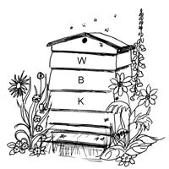
SURREY BEEKEEPERS' ASSOCIATION

WEYBRIDGE DIVISION

NEWSLETTER: September 2017

www.weybridgebeekeepers.weebly.com

Editorial

Like many other organisations, our own has passed through a number of phases, even in living memory. For at least 20 years our membership numbers and activities were pretty static. Nearly all of the 35 or so members knew each other, and attended most of the garden meetings (more or less the only meetings that we had at that time). The next phase started when winter meetings were introduced, then 8 years ago, we began our beekeeping for beginners courses. Considering that no advertising was done for these initially, we wondered where the students (about 20 most years) came from; probably the result of the problems with honey bees that came to the attention of many inside and outside of parliament (and hence the media) at the time. This led to a significant increase in our membership, to well over a hundred in a short time. The progress and interest of some of our students has been most encouraging, with some embarking on beekeeping and queen-rearing activities on quite a large scale. It has also given some of us much pleasure to see the understanding and initiative of others with just one or two hives. Our website was set up during this period and provided welcome new publicity for the group. Then, more recently, came a generous legacy via one of our members which has instigated the initiative to set up our own permanent beekeeping centre, the stages of which you have been able to follow each month. On a personal note, it has been good to experience the willingness to respond to my appeals for contributions to the newsletter, whether by specific request or by those unsolicited ‘sent in’ ones. With all this enthusiasm we shall be in a good position when we finally have our base in Pleasant Place, Hersham, where we should reach even further heights with our activities and even more importantly with our bees; they certainly need all the help that we beekeepers can give them.

Subscriptions

The time for renewal of subscriptions has arrived. All subscriptions expire on 30th September each year regardless of when the subscription is started. The 2017/18 subscription form is attached and should be completed and returned to Michael Main. This may be done electronically by attaching it to an email (see near bottom of page 1 for email address). Payments should preferably be made electronically using the details shown on the form. All renewals should be done by the end of October after which non renewals will cease to have BDI cover, BeeCraft and BBKA News. As I will be away on holiday no reminders will be sent although there will be a note in the next Newsletter advising cancellation of non renewed subs.
Michael Main (Treasurer)

As explained in the email sent recently to all newsletter recipients who are not currently members, now is the time to choose to remain in touch by becoming a Friend of Weybridge Beekeepers (£5 per annum). After the October issue, Newsletters will only be sent to Members and Friends.

Potential Beekeeping Centre in Pleasant Place, Hersham: Update 9.

Things are moving!

We now have a date: September 20th for the Elmbridge Council meeting to approve our Head of Terms (HOT) lease agreement. The exact time and venue will be confirmed in a separate email that will be sent out in about a week; it is likely to be 10am at the Elmbridge Council Civic Centre in Esher. This is a Wednesday so we know it may be hard for some members to attend, but for those who can make it we would VERY much encourage and request you to do so. The meetings are open to the public and a strong contingent from Weybridge Beekeepers is important in order to help ensure a smooth approval process. Assuming we have approval at the meeting on the 20th, then formal approval will come with the publishing of the minutes on the 22nd September.

Based on the above, the project team expect to be in a position to hold the Extraordinary General Meeting (EGM) with fully costed plans early in December – maybe over a mince pie and mulled wine. The overall timings we are now working to are:

· Dec 2016 Business Plan submitted
· Sept 2017 Elmbridge Council HOT agreed
· Sept/Oct/Nov Surrey BKA Trustees approve HOT
Detailed plans drawn up for costs and planning application
· Nov/Dec Weybridge Beekeepers EGM for approval
Planning application process
Start fundraising
· Jan – June 2018 Complete fundraising and select contractor
· June – Nov Carry out work
· Dec Move into building
· Jan 2019 Move bees into apiary
· Jan First session of theory course in new premises
· April First session of practical course at new premises

It is a long journey and has not been as fast maybe as some of us had wished but, all going well, things are now moving and given the current problems with the Division’s apiaries highlighted later in the newsletter, the importance of having our own Teaching Apiary with full security (e.g. lights, cameras, secure perimeter, etc.) has been clearly demonstrated.
David Parker

The Association’s second honey extractor (see July Newsletter page 4)
Rob Allen has kindly offered to look after this extractor for us. Thus our two extractors are available for hire as indicated in the following note.

Honey extractors for hire
We have two honey extracting kits for hire to Weybridge BK members @ £5 per day or part of a day, plus £10 deposit. One extractor is available from Anne Miller, anne_r_miller@hotmail.com, and for the other one contact Rob Allen, roballen82@virginmedia.com.

Vandalism at the Weybridge Division’s Apiaries
We are very saddened to have to report that the hives in our Teaching Apiary in the grounds of St George’s Junior School in Weybridge have been pushed over on several occasions recently. Fortunately, the bees have survived, and members will be able to repair the damaged hives. After the third incident it was decided to take advantage of a very kind offer by one of our members to house the colonies at least for the winter so that the matter could be reviewed again in time for the teaching sessions next spring. Tim and Sally Hutchinson, our Apiary Managers, will manage the bees in their new location, but will now have no reason to visit the site regularly, so we are grateful for the offer of help from a member of the school staff who passes the apiary on his way to work. He notified us of these incidents, and has kindly said he will continue to keep an eye on the site and let us know of any further incidents, particularly relating to the shed, which contains valuable beekeeping equipment, and obviously can’t be moved very easily.
There has also been recent vandalism at the Burhill Allotments site in Hersham, where the Division had an apiary that had to be vacated because of problems with plotholders. A chain on the gate has been broken, the padlock taken, the shed destroyed and some stone slabs removed. As already explained in a previous Newsletter, the Division will not be renewing the tenancy, but this is a sad ending.

REPORTS
Apiary Meeting with Arran Taylor, Byfleet, Saturday August 12th
It was a pleasant dry day when we arrived at Arran’s house where he has his Apiary. Seventeen members had turned up for what was to be a very interesting afternoon’s meeting. Arran called the meeting to order and explained that we would all be helping to put virgin queens into mating nucs (Apideas). He showed us a Cup-Kit Queen rearing system which he used to get the queen to lay her eggs in, and then described the process of mounting the cell plugs onto a frame for insertion into the breeder hive. To start with each person was given an Apidea and required to check that it had three frames with just starter strips of foundation for the bees to draw and that the feed box was fully charged with candy. All the required materials were supplied. Once the boxes had been prepared each of us was given a queen cage containing a virgin queen and its attendant workers, and were asked to separate the queen from the workers by releasing the workers without letting the queen escape. One member who shall be nameless let his queen escape, but there were enough spares and everyone succeeded eventually. Each queen and a ladle full (approx. 300) of nurse bees were then sprayed with a sugar solution before placing both into the upturned Apidea where the floor had been slid out. The Apideas were then closed up and placed in the shade ready to be taken to their mating locations. Then Arran showed us some Polish mating boxes that were larger than the Apideas and in which he planned to overwinter some mated queens. These boxes cost just £10 in Poland.
Before we adjourned for tea we all had a look into his Workshop, Storage room and Extracting room. These were on an industrial scale and the extracting room contained two computer-controlled extractors, a heated honey filter with pump and a very large wax extraction tank all of which would not look out of place in a Bee Farmer’s outfit. Outside the sheds, the walls were lined with beehives (all containing bees) in varying shapes and sizes; I did not count how many but their must have been around 40. Not bad for someone who started beekeeping only just over a year ago.
Thank you Arran and your wife for your welcome, and a most enjoyable afternoon which enriched our knowledge of queen rearing.
Michael Main

Taster Days for potential new beekeepers for next year’s course – a report and a blog
Two Taster sessions were held in August at the Teaching Apiary behind St George’s Junior School in Weybridge. An encouraging number (more than 20) attended and showed a pleasing interest. A very interesting attendee called Ashleigh was recommended to attend by the editor of the local publication called YourElmbridge, who had already planned to attend herself. Ashleigh wrote asking if she could come to the session saying, “I write a blog where I do something new each week, and I'd be so interested in coming to your beekeeping taster day on the 16th August. Please let me know if this is possible!” She was, of course made welcome, and sent an email afterwards saying, “Just wanted to say a huge thanks for last night - I really enjoyed the session!” Do read her blog: www.fiftytwo52blog.wordpress.com Sue Lawes
EVENTS IN SEPTEMBER

September Apiary Meeting – Social Event / BBQ, 9th September, 1pm
Here are the final details and arrangements for this event:
Thank you to everyone who responded and in fact we now look like having a good number of people there. There is loads of land and room so kids and family members are welcome. The aim is to kick off at say 1pm, with the BBQ going and enjoy a leisurely afternoon, maybe even look at a few bees for those that want. People without bee suits can also view the bees safely from behind a viewing window so no need for them even to get into a bee suit – perfect for little kids. There will be rolls, and some sausages and burgers but please feel free to bring a salad, any other meat/desserts.
Attached is the PDF of the map prepared for the July Garden Meeting of how to get to Paul and Helen’s field for the BBQ, along with an aerial view of the site. FREE fuel for smokers is available, so bring a bag as there are loads of grass clippings and also piles of wood chippings.
There are facilities to make tea and coffee, so no need to bring flasks and mugs. There is also a toilet.
Bring the rug/chair, hopefully the sun will make an appearance and the committee look forward to seeing everyone there. If you have not already done so, please let me know soon if you intend to come. David Parker E: davidparker@polymathconsulting.com

FUTURE EVENTS
Weybridge Beekeepers’ AGM
Saturday 11th November. Full details later.

Bee Improvement for All
West Sussex BKA and BIBBA have arranged an event in November which may be of interest to your members. Its aim is to help all beekeepers improve their bees. Full details are available in the attached document and are also available on the WSBKA www.westsussexbeekeepers.org.uk
and BIBBA websites.
Graham, Secretary West Sussex Beekeepers' Association

86th National Honey Show, Sandown Race Course, Esher, 26-28 October
Details in April Newsletter p. 4, the July newsletter p. 3. and on the National Honey Show website.
A request for volunteers to assist on the Surrey Beekeepers Stand at the National Honey Show is attached. Further details of the Show have been sent to us as an email; this will be forwarded separately as it is too large to reproduce here.

Central Association of Bee-Keepers Autumn Conference Friday 17th - Sunday 19th November
This Annual Conference will be held this year at the usual excellent venue near Kenilworth. Full details of the event and the speakers will be found at www.cabk.org.uk/events/autumn-conference/ or ‘Google’ it as ‘CABK conference’.
A number of our members have attended this conference over many years, and will vouch for the quality of its many aspects, not least the delightful setting and accommodation. We hope that you will seriously consider attending this event.

ITEMS OF LOCAL INTEREST
A site for a hive
Jane Hunter recently received the following email:
‘I am keen to offer my garden… I don’t think I have the time to manage one myself but would learn a lot from someone keeping a hive at mine’
Can anyone help? If so, please contact Carolyn: carolynwong@me.com‬‬‬‬‬‬‬‬‬

One-day workshops on pollen

We have received the following from one of our members who works on pollen at the Natural History Museum in London.

I shall be running a series of workshops throughout September and October: website pollenandbees.com
A quick course description;
Pollen and Bees workshops for 2017.
A new workshop which demonstrates the ease with which slides of pollen can be made from flowers, pollen loads, pollen stores and honey has been created for beekeepers. It is an interactive workshop and participants will be making slides of pollen for examination under the microscope.
Participants are invited to bring pollen loads, pollen stores samples and their honey from which they can make slides of pollen.
Taking pictures of pollen using mobile devices will be demonstrated and participants will be given the opportunity to take pictures and upload to the pollen and bees website for identification.
A talk on honey bee nutrition, non-laboratory authentication of honey, and a citizens science project for beekeepers will take place in the afternoon session. How to fingerprint your honey will also be discussed.
This course has been created for beekeepers but is open for anyone to attend.
Jonah Chitolie
A few of us have already had the privilege of seeing some of Jonah’s very impressive methods; attendance at one of the sessions is highly recommended. Marion Cooper

Hive weight changes

(1) From David Brassington

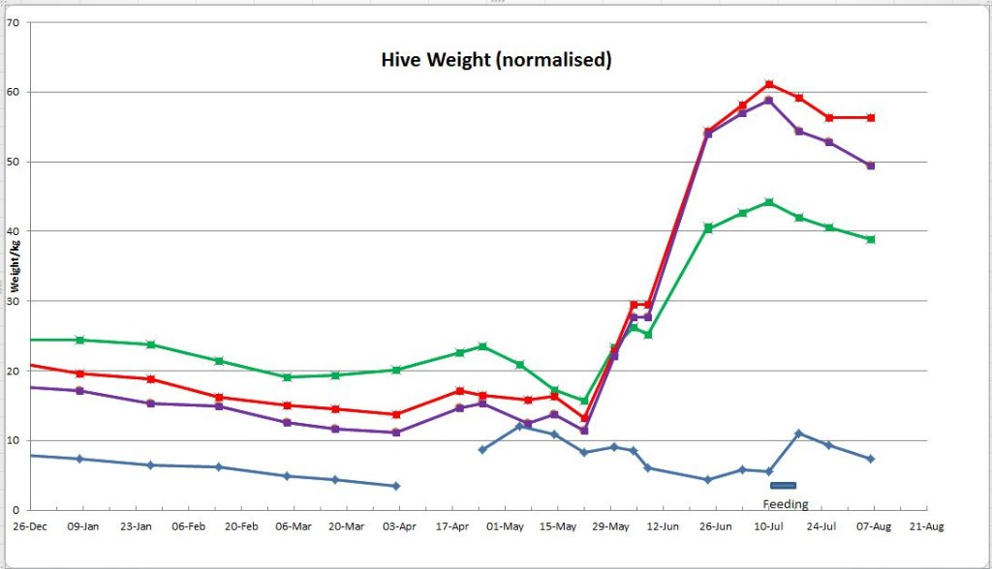

(2) From David Parker

My weight is going up??

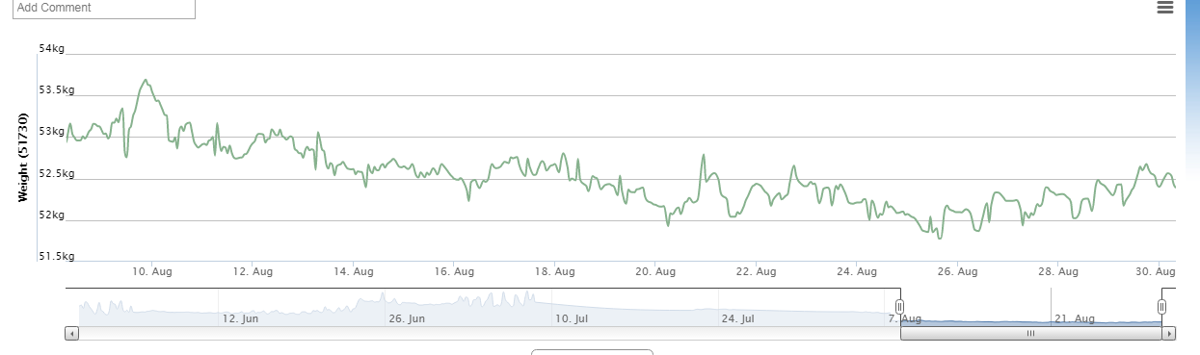

(3) From Geoff Cooper
I am afraid I have no results for August as I assumed that there would be only a decrease in weight, so did not zero the balance to take further readings after I removed some of the honey for extraction. However, I hope to reset the equipment and provide some more figures next month.

A ‘great find’ in this country – a Carpenter Bee
Last month we reported this very exciting find by Richard Emmett in our area. He has now sent us a photograph of another recent siting of the bee in his sister’s garden in Send. You can enjoy this photograph in the attachment.
Thank you Richard.

More on carpenter bees - and others
Following the item from Richard in last month’s Newsletter, I had this most interesting communication from Christian Burgar, one of our members who does not have honey bees, but ‘keeps’ Mason bees – he wrote:

‘I was very interested to learn that another 'bee keeper' was visited by a Carpenter bee this year. I had possibly three, but definitely two in the garden in the early summer and it was their dark colouring that sparked my interest as I was sure that it was not something I had seen before. I had to look them up online and use my bee identification cards before I came to the same conclusion. They were flying around a large lavender bush (9 ft tall) and the first flowers of my everlasting peas.
At the same time there was a plethora of Leaf Cutter bees around with their classic lower half of their abdomen covered in bright yellow pollen, which can sometimes make them look like a new species.
As you may recall, I 'keep' Mason bees and was an original member of the Oxford Bee Project. Two years ago I experienced a total collapse of the bees and they were late again this year in both waking up and becoming active, but by mid season there were signs of some activity.
Last year I also had a colony of the parasitic wasp the Organ Pipe Mud Dauber (Trypoxylon politum), which is a dark sinister looking wasp - quite beautiful - it hunts spiders and leaves nest chambers that look like mud organ pipes in parallel. Mine were located on wooden posts. I had seen the wasps in the summer, but only found the organ pipes in early spring of this year. I have not seen any Bee parasitic wasps this or last year, but previous to this, it was quite common to see one or two during the early part of the season.’

Elmbridge Natural History Society
Members may be interested in attending some of the meetings of the above Society to which some of us belong. In winter they run monthly meetings addresed by very knowledgeable speakers on a wide range of natural history topics, and in summer a varied series of outdoor events.
Visitors are always welcome for a very small charge. Details on their website: www.enhs.co.uk.

ITEMS OF GENERAL INTEREST

General Husbandry Assessment training
Please click on this link underlined blue link for information from the Education and Husbandry Committee of the BBKA, on preparation for the General Husbandry Assessment.
Marin Anastassov, General Husbandry Training Organiser

Volunteer needed to welcome a National Honey Show Speaker from Canada at Heathrow Airport
We very much hope we'll be able to arrange a volunteer to give one of our international speakers a personal welcome and departure. She is Heather Mattila, incidentally - SBKA are sponsoring one of her talks at the Show - 'Well-Mated Queens Produce the Busiest Bees' (Friday 27 October). I have attached a few details and photo of Heather.
Heather is arriving at Heathrow at 9am on Thursday 26th October. She is speaking on Thursday afternoon so will just need to be collected from Heathrow and taken to Sandown Park Lodge to freshen up.
Heather is flying straight back to Canada after the show so will need to be taken to Heathrow on Sunday 29th October. Her flight on Sunday is at 9.20am so she will need to be at the airport by 7.20am. That probably means leaving Sandown Park lodge by 6.30am!
We also need to think about entertaining her on Saturday evening. The show team will be flat out striking the show so we would really love to allocate someone from Surrey BKA to entertain Heather.
If you are able to assist with airport pick up / return or ideas for Saturday evening. Can you drop me a line and copy in Bob Maurer?
Thank you so much for your assistance with this request.
Julie Hogarth (Surrey BKA Secretary)
A journey to Heathrow is not exactly a joy, but what a privilege to meet and entertain someone like this.

Winter help from the National Bee Unit
We have compiled an autumn management checklist to help you successfully overwinter your colonies. This document can be found on the front pages of our website in the 'Recent NBU News' section. To view it please click here.

Some attractive beekeeping equipment prices?
This has arrived in my inbox. Normally I ignore advertising, but the prices quoted here look very good, and the pictures seem sensible. I thought it would be worth passing on to the members.
The equipment is from a firm in Lithuania (http://Beehivemaster.eu). A picture of a sample hive is attached. This hive, fully assembled, costs £52.
Jane Hunter
Thanks for this Jane. Beekeepers are always looking for good prices.

FOR SALE

Neither the Newsletter Editor nor Surrey Beekeepers Association take any responsibility for the accuracy of any of the following entries, or for the condition of any of the items advertised. If considering purchasing bees or secondhand equipment, the prospective purchaser should take great care to ensure that the bees are not diseased, and that all equipment is sterilised before use. Inexperienced purchasers should take a knowledgeable beekeeper with them.

Two Octagon Hives for Sale
There is one of each of lilac (unused) and yellow(one season’s use). There is an observation window in each box and optional opening at each level with a queen screen on the lowest box. The boxes are top bar hives, but also operate with 6 national brood frames in the centre of each box. The stand has a mesh floor. Offers sought around £150 per hive. Please contact Linda Pakuls: 078590 895085 or email linda@smenos.co.uk
An illustration of this type of hive can be seen in an attachment.

Hive components for sale
I have a quantity of hive components – enough to make three hives – for sale at £5.00 per unit. If interested contact me on phil@swan-walk.co.uk.
Phil Roberts

Local bees for sale
Available now, overwintered 6-frame nucs and 12-frame colonies of British-bred Buckfast bees with brood in all stages and headed by marked, 2016 Buckfast queens from Ged Marshall. The bees are strong, healthy, gentle and hardworking; they are on clean combs and have been treated for Varroa. Currently housed in Payne’s poly nuc boxes, but if preferred can be transferred to your own hive.
Nucs from £150, Colonies from £200. Cash on collection, please.
Call Arran (Weybridge member) on 07713 629189.

Bees for sale
A number of established COLONIES (National Standard Hoffman brood frames) with a new 2017 mated queen will be available for sale. Our bees have a gentle temperament and are good foragers. All queens are locally reared from our gentle breeding stock. Price of each colony varies depending on the size of the colony (on number of brood and super boxes). Single brood box colony £175. For more information, please contact me – details below.
Contact: Astrid Bowers-Veenman (Hog's Back Bees and Bee Products)
Location: Ash Green (between Guildford and Farnham, just off the A31)
Distance from Weybridge: 12 miles (as the crow flies)
Tel. No.: 01252 330229 / Mobile: 07803 069798 / Email: astrid@coginternational.co.uk
Feel free to contact me if you have any questions.

Dates for your diary
Saturday | September 9th | 1 – 5 pm | Social / BBQ, Rowtown | p. 4
Saturday | September 9th | All day? | West End and Windlesham Show, with honey section | August p. 5
Saturdays | September - October | All day | Pollen Workshops | p. 5
Thursday-Saturday | October 26th-28th | All day | National Honey Show, Esher | p. 4  NHS website
Saturday | November 11th | 2.30 pm | Weybridge Beekeepers AGM | Details later
Friday-Sunday | November 17-November 19 | 5.00 pm  9.30-4.30 pm | CABK Conference | p. 4
Saturday | December 2nd | 2.00 pm | Surrey BKA AGM, Croydon | July, p. 3
Monday | January 22nd | 7.30 pm | First session of Beginners’ Course (Theory) | July, p. 3

CONTACT DETAILS
Chairman  Andrew Halstead - 01483 489581  email: ahalstead44@btinternet.com | Secretary  Jane Hunter - 01932 857427  email: weybridgebees.sec@gmail.com
Treasurer  Michael Main - 01932 849080  email: michaelfmain@hotmail.com | Newsletter Editor  Geoff Cooper - 01932 242179  email: coopergm56@btinternet.com
Rowtown Apiary Manager  Rob Chisholm - 01483 715779  email: robinchisholm102@btinternet.com | Teaching Apiary Managers  Tim and Sally Hutchinson - 01932 962094  email: olddrone58@gmail.com
Beginners’ Beekeeping Course Tutor  Andrew Halstead - 01483 489581  email: ahalstead44@btinternet.com | Swarms  Michael Main – 01932 849080  email: michaelfmain@hotmail.com
Beekeeping Refresher Course / BBKA Basic  Tim & Sally Hutchinson  email: info@beehappyproducts.co.uk | Membership Secretary  Peter Webb  email: peterwebb@btinternet.com
Education Coordinator  Edwina Wardle – 01932 702887  email: Wardle_1@ntlworld.com | Beekeepers Beginners Course - Admin  Sue Lawes  slawes@hotmail.co.uk
Regional Bee Inspector  Sandra Gray – 07775 119430  sandra.gray@apha.gsi.gov.uk | Seasonal Bee Inspector  Hilary Hayward - 07900 167409  Email: Hilary.Hayward@apha.gsi.gov.uk

LOCAL BEE ADVISORS
Rob Chisholm - 01483 715779 | Geoff Cooper - 01932 242179

Paul Hildersley – 07827 916186

